# Bulk suspend users

You can bulk suspend users from your site. It is highly recommended that you test this on one user before doing bulk suspensions.

You can also reverse this process, and bulk unsuspend users.

**The process is:**

1. Go to *Site administration> Users> Accounts> Upload users*
2. Upload your .csv file

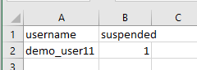

1. Click on ‘upload users’

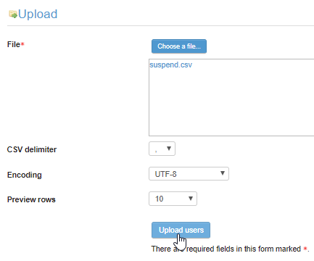

1. In the settings, select ‘update existing users only’

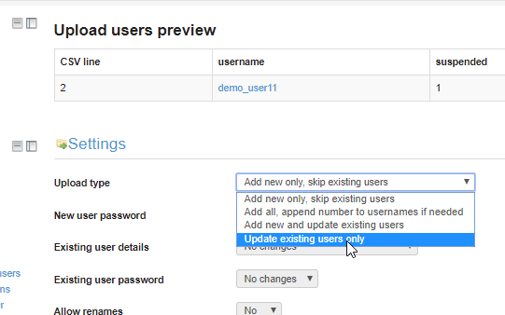

1. Make sure ‘suspending and activating of accounts’ = yes



1. Moodle will give you a report

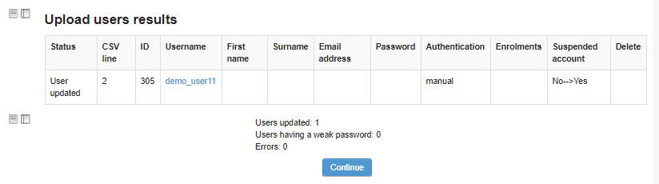

# Unsuspend users

If you would like to unsuspend users, you can do the same process. However, put a 0 in the ‘suspended’ column of your .csv file.

