# Using competencies in your course and content

This is the process for using competencies. The first two steps are done by TVC administrators in your site, and we looked at doing this in a previous video.

The next two steps can be done by the person creating the course, and we’ll look at doing this now.

First you add the required competencies to the course, then you can allocate them to the appropriate activities in the course.

Before you add competencies to your course and activities, you should have mapped out what the student needs to demonstrate in order for competency.

## Map activities to competencies

|  |  |  |
| --- | --- | --- |
| **Competency** | **Course** | **Activity** |
| [BSBITU201](https://training.gov.au/Training/Details/BSBITU201) - Produce simple word processed documents | BSB20115 - Cert II in Business - computing skills 2017 (Computing skills) <http://moodle31.trainingvc.com/course/view.php?id=12> | **Database** Word shortcuts |
| [BSBITU202](https://training.gov.au/Training/Details/BSBITU202) - Create and use spreadsheets | BSB20115 - Cert II in Business - computing skills 2017 | **Assignment** Salary calculation |
| [BSBITU203](https://training.gov.au/Training/Details/BSBITU203) - Communicate electronically | BSB20115 - Cert II in Business - computing skills 2017 | **Quiz**  Email quiz |
| - Use business technology | BSB20115 - Cert II in Business - computing skills 2017 | **Chat**  Chat room |

# Add competencies to course

Add the competencies that apply to your course. These competencies can then be used in your activities.

1. Create the course you are to use (or edit an existing course)
2. Go to this course
3. Go to Administration> Course administration> Competencies
4. Click on ‘Add competencies to course’

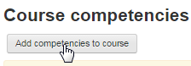

1. Choose the appropriate framework, then the competencies, then ‘Add’.

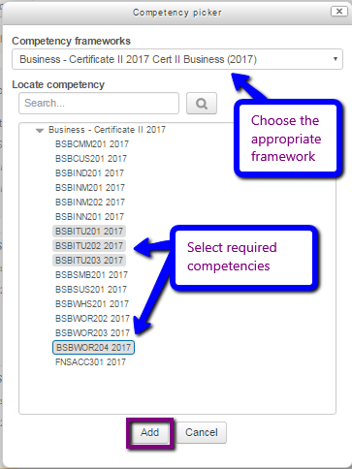

# Add the competencies to activities within the course

Note:

1. In the settings of your activities, use the bottom ‘Competencies’ section to choose the appropriate competency/competencies the activity relates to.
2. If completing this activity **does not** demonstrate that the competency is yet demonstrated as ‘competent’, then select ‘do nothing’ for ‘Upon activity completion’.
3. If completing this activity **does** demonstrate that the competency is yet demonstrated as ‘competent’, then select ‘Upon activity completion’ = ‘complete the competency’.

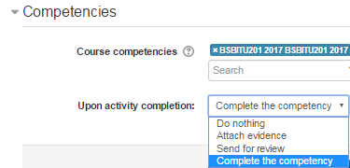

# Use activity completion settings

In this simplistic example, the student will demonstrate competence when they complete an activity.

The following student has completed activity ‘Word shortcuts’, so has completed one of the four competencies in this course example (25%).

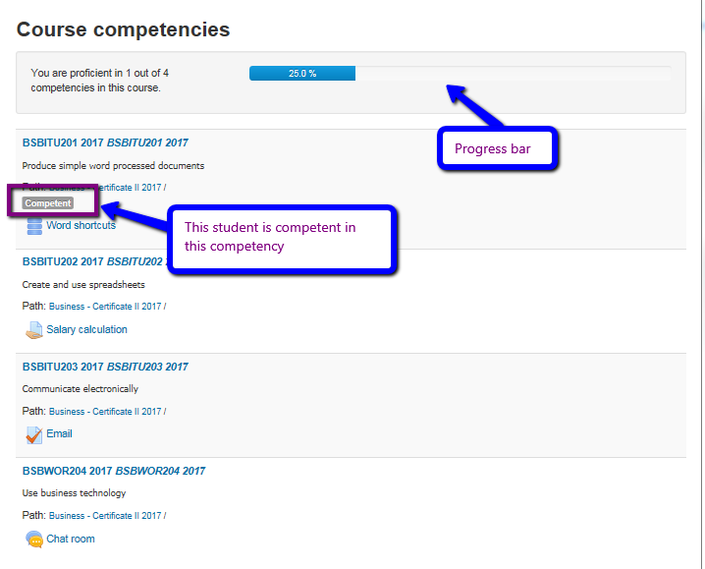

Once competencies are set up in your courses, you may like to take advantage of Learning Plans. Learning plans are a set of competencies that can be assigned to students.