# Competencies

By default, only your TVC Administrators can set up competencies for the site.

(Competency> Element> Performance criteria)

1. Create Scale if required (eg Did Not Submit, Not Yet Competent, Competent) before creating Competency Frameworks
2. Create competency – Administration> Site administration> Competencies> Competency framework; ‘Add new competency framework’
   1. Give the competency framework a name and ID number (maybe include the year, eg ‘ABC – 2016’)
   2. Select ‘competence scale’

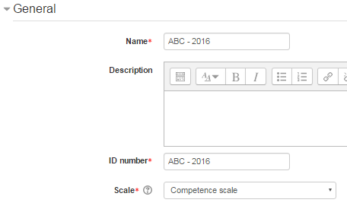

* 1. ‘Configure scale’
     1. Choose the default value, perhaps ‘Competent’
     2. Choose when to show as Proficient, perhaps ‘Competent’
     3. ‘close’

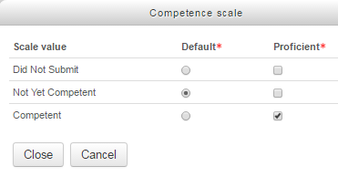

* 1. Taxonomies – perhaps:
     1. Level 1 – competency
     2. Level 2 – Skill
     3. Level 3 – Skill
     4. Level 4 – skill
  2. Save changes

1. Click on the newly created Competency framework

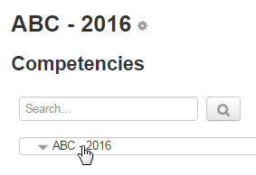

1. Click on ‘Add Competency’

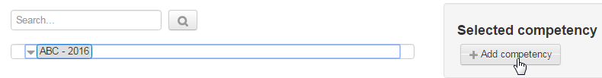

1. This is ‘Level 1’ which we have defined as a ‘Competency’. Give competency a name and ID number, then ‘save changes’

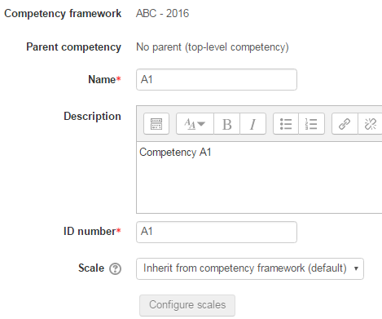

1. Click on the newly created competency



1. Click on ‘Add skill’ (this is Level 2, so a skill as we defined it in the ‘Taxonomies’)

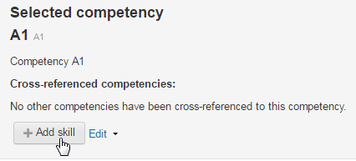

1. Give the skill a name, ID number and description. You could think of this as equivalent to an Element. Then ‘save changes’.

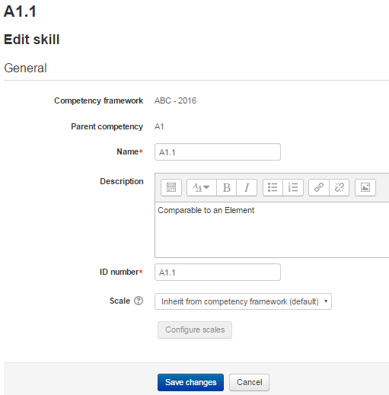

1. Click on the newly created ‘element’



1. Click on ‘add skill’



1. Add the next level skill – you could think of this as comparable to a Performance Criteria. Then ‘save changes’.

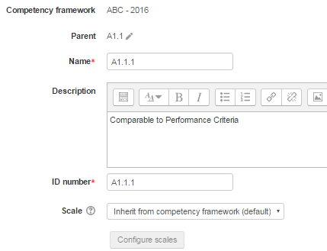

1. Click on the A1.1 to create another ‘Performance Criteria’



1. Add skill



1. Add details, then ‘save changes’

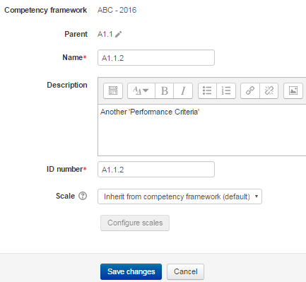

1. Keep creating the competency Framework until it is completed.

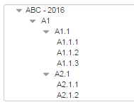

Now do your course preparation…