# Add a YouTube to your TVC Repository

In summary, the process to add a YouTube to your TVC Repository for use in Moodle is to:

1. Log into the web front of your TVC Repository
2. Create an HTML page
   1. Copy the embed code of the YouTube
   2. add the YouTube embed code you have copied – then save
3. Go to your Moodle course
4. Add a File resource (using the HTML page you created in the TVC Repository)

**More detail:**

## Log into the web front of your TVC Repository

1. Log into <https://lcms.trainingvc.com.au> (submit a ticket if you are not sure of your details)

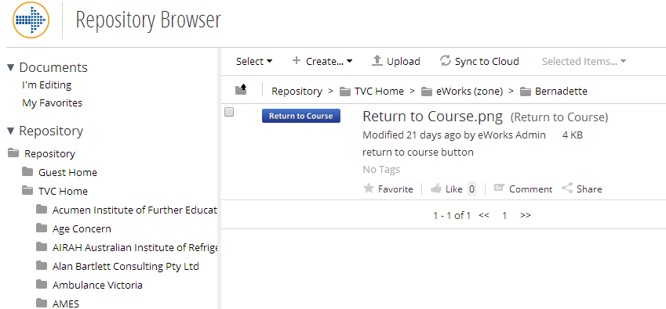

## Create an HTML page

1. Go to the folder you want to use
2. Click on the Create drop down, and select ‘HTML…’

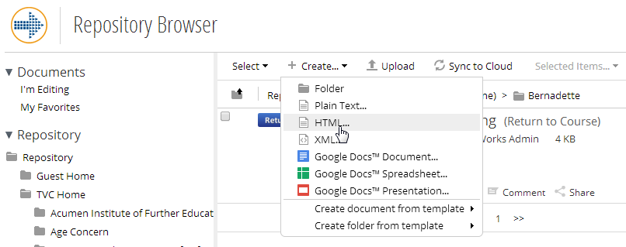

1. Add an appropriate name, title and description
2. In the ‘Content’ box, click on the ‘HTML’ icon

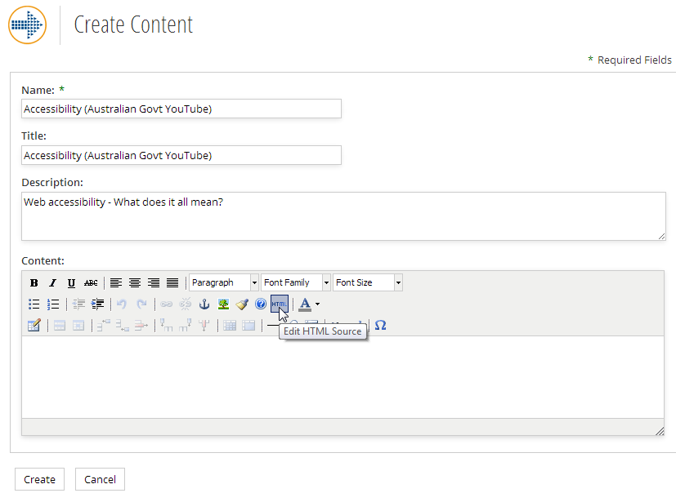

1. Add the embed code to the popup, then select ‘Update’ *(see following section on ‘Copy the YouTube embed code’ if you are not sure of how to find this).*

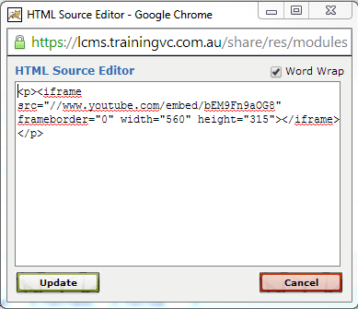

1. Select ‘Create’ (at the bottom)
2. **PLEASE NOTE:** **you will not see the YouTube as expected from the web front of your TVC Repository, but it will appear correctly from Moodle.**

## Add YouTube to your Course

1. Go to your course
2. Add a File resource

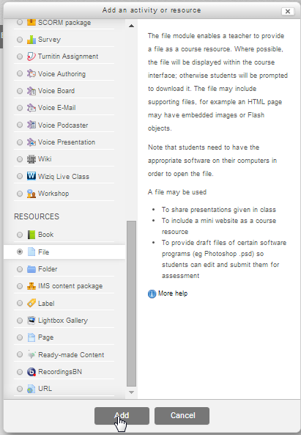

1. Click the ‘Add…’ icon to get to the File Picker

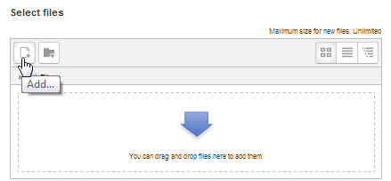

1. Select the YouTube item you just added

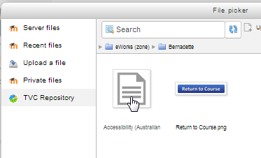

1. Choose ‘Select this file’
2. Suggestion:
   1. Select ‘In pop-up’ for the display
   2. Choose ‘show more’ and use Width = 1024 and Height = 768
   3. Set the completion tracking if required
3. Select ‘Save and return to course’

## Copy the YouTube embed code

1. Go to the YouTube page you want to use
2. Click on ‘Share’ (underneath the video)

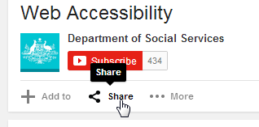

1. Then click on ‘embed’

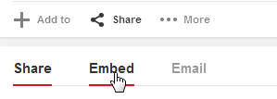

1. Copy the ‘iframe’ code

