# Find forum posts by individual students

* Go to the forum



* Select the *Search forums* button at the top of the page 
* Fill in the search terms, as required, then click *Search forums*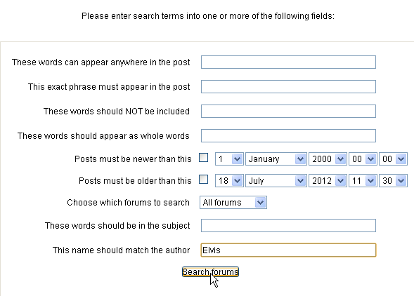
* You will then see the posts by that student

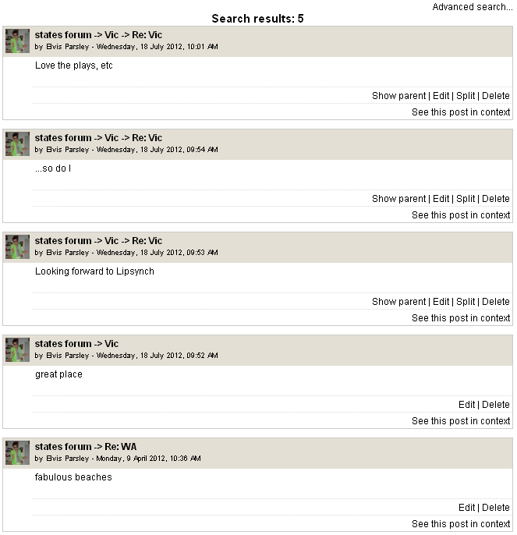

To see the post in context, click on *See this post in context*