# Discussion forums: editing, deleting and splitting posts

The followiing explains how a teacher can delete or edit student posts (eg if the post is inappropriate, spelt poorly, incorrect, etc).



* You can click on a discussion

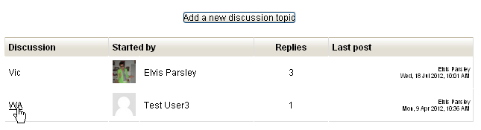

* From here you can edit, or delete inappropriate forum posts. You can also split the discussion if you believe the post should be its own discussion topic.

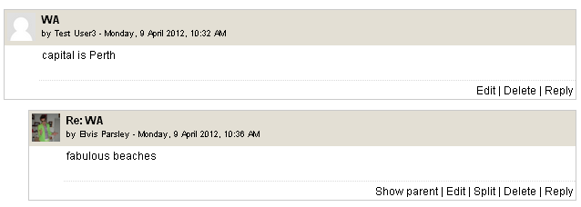

* If you are splitting the discussion, you will get prompted to confirm…

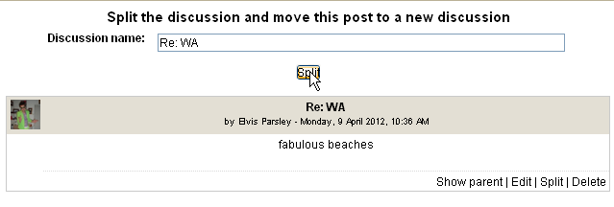

* Then the forum will then look like…

