**Create new courses from a Template**

**Process:**

1. Create a course to be the template
2. Backup the course
3. Restore the backup as a new file

### Create a course to be the backup

Create a new course and add the blocks, topics, etc as required for your template.

## Back up the course

* Go to the course to be backed up.
* Click on Course admin> Backup

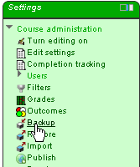

* Tick off *Include enrolled users* (unless you want to include them)

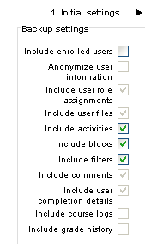

* Check the next page (*Initial settings*) and then click on **Next** at bottom of page
* Click on **Perform Backup** at the bottom of the *Confirm and review* page (the name of the backed up file is listed near the top of this page)

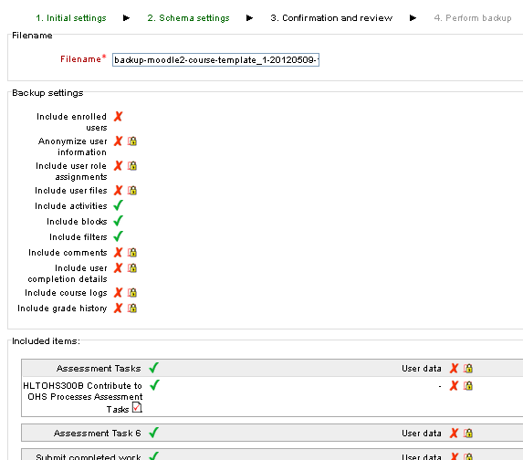

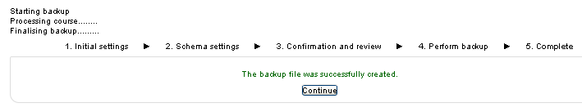

* Click on **Continue**  and you will be taken to a page headed **Import a backup file**

## Restore from the backed up file

When you have backed up the course, you will end up on a page that will allow you to go straight into restoring this course. If you have not just backed up the course, then go to a course, and go to Settings> Restore

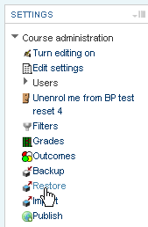

Click on **Restore** next to the course to be restored:

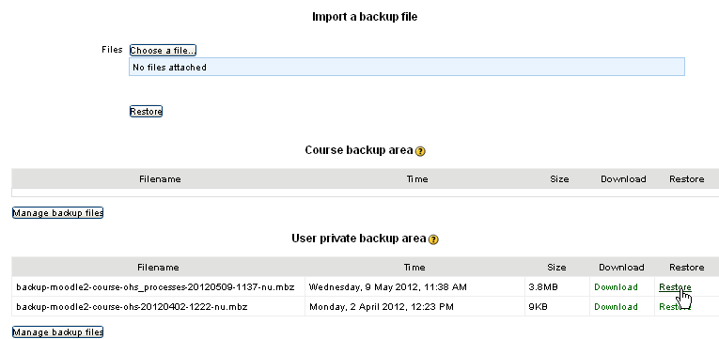

* When the **Confirm** page opens, click **Continue** at the bottom of the page
* Click on the category you want the course restored to, then click on the **Continue** button just underneath (to *Restore as a new course*)

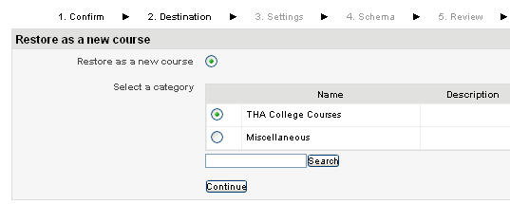

* Click **Next** on the *settings* page

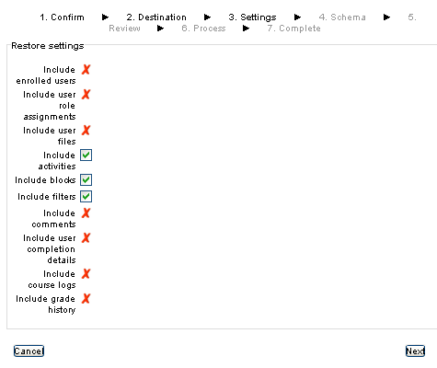

* On the *Schema* page, change the Course name and the Course short name as required

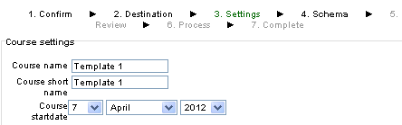

* Then click **Next** on the Schema page
* Click **Perform Restore** on the bottom of the *Review* page. Moodle has to do a bit of work to do here… so wait for it… When it is complete, you can click on the **Continue** button and you will get taken to the new course.