# Prevent students from creating a new forum discussion

You need to have Administrator rights (teachers can’t do this).

## To prevent students from creating a new forum discussion for one particular Forum

* Go to the Forum
* Got to *Settings>forum administration> Permissions*
* Click on the X next to the Roles you want to prevent from starting a new discussion topic



* The student will no longer have the *Add a new discussion topic* option when they go to the forum

## To prevent students from creating a new forum discussion for all Forums

* Go to *Settings> Site admin> Users> Permissions> Define roles*
* Click on ***Student*** 
* Click on *Edit* button (at the top) 
* If the button just above all the Capabilities (see below) says *Show advanced*, then click it (it will then display *Hide advanced*)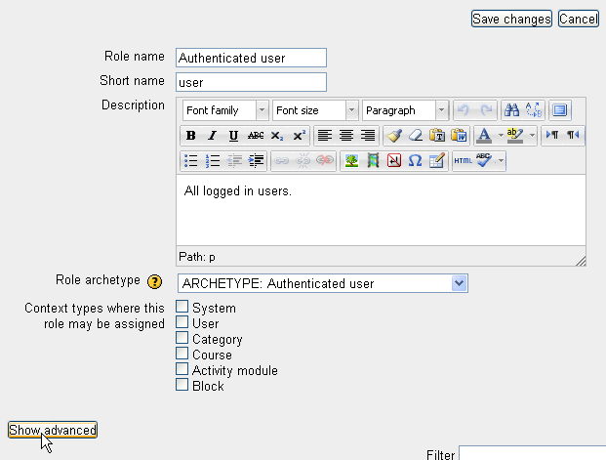
* To find where to change the settings, **Find**  the word by using the short cut *Control F*
* Type **discussion** and search for the term
* Change the setting for *Start new discussions* to **Prevent**
* Save your change