# Find forum activity by a user

* Go to Navigation> My courses> (course name)>Reports

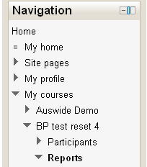

* Choose your options…
  + These options will show all activity by user Elvis Parsley in the forum called *States forum*

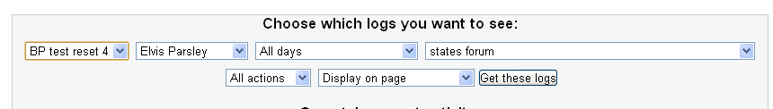

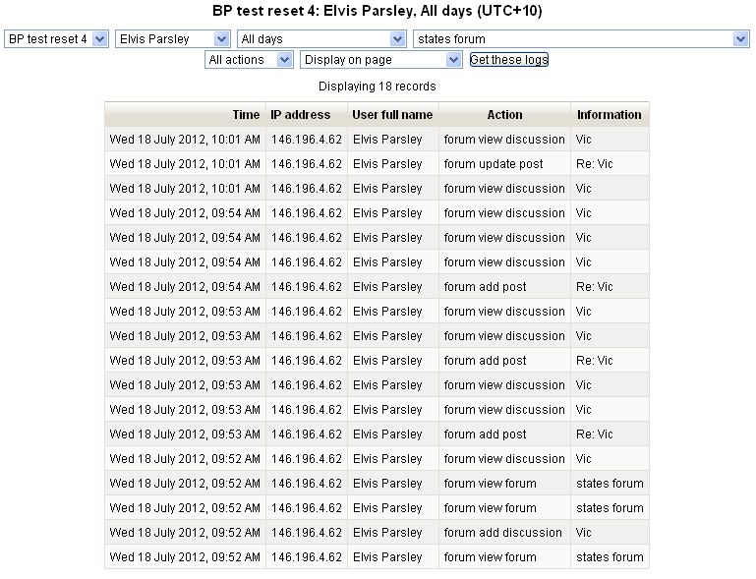

If you change *All actions* to *All changes* you will see the posts and edits the student has completed…

