To delete a test attempt:

* Go to the course which contains the quiz
* Go to Settings> Grades

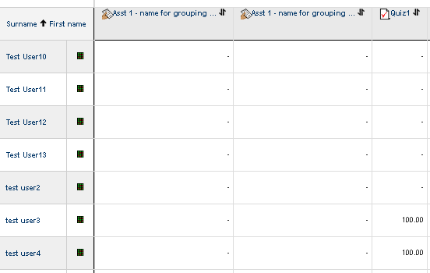­

Then select the attempt you wish to delete

Then click ‘Delete selected attempts’

Click on the name of the quiz

