# Zoom

## Create Basic Zoom account

1. Teacher to create a Basic Zoom account from <https://zoom.us/pricing>
2. Click on ‘Sign in’ 
3. Log into <https://zoom.us> using the email address and password as created for your account
4. You should be on the ‘My Profile’ page
5. Note the ‘Personal Meeting ID’ URL

# Add a Zoom meeting to your course

An editing teacher can add a Basic Zoom account to TVC Moodle using the URL or External Tool activities.

## URL: Teacher creating and using

### Add resource URL

1. Teacher with Basic Zoom account logs into TVC Moodle course
2. Create a ‘URL’ resource ie ‘*add an activity or resource’> select Resources> URL’*
3. In the ‘External URL’ setting put in your ‘Personal Meeting ID’ URL
4. Give this activity a name
5. ‘Save and return to course’
6. click on the new 'zoom room' link
7. *Note: you may need to log in the first time:*
   1. *select 'zoom meetings' by clicking ‘Open Link’ in the ‘Launch application’ popup*
   2. *message: 'please wait for the host to start this meeting'*
   3. *log in to meeting, and meeting starts*

### URL: student using

1. Student logs into course, and clicks on the 'zoom room' link
2. click 'open' in 'Open this page in Zoom?' popup
3. accept name of device by clicking 'continue' for device name
4. they’re in!

### Notes

* student can’t log in until the host is in the meeting. They see

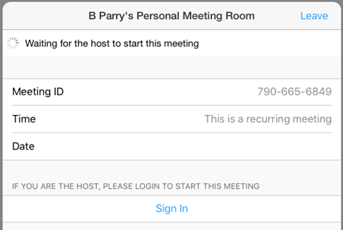

* when teacher gives remote control to student, student can write/doodle on the screen, add text, basically control the screen being shared.
* teacher can make student 'host' - student can then mute/unmute others

## LTI: Teacher creating and using

1. Teacher with Basic Zoom account
2. log into your course

### Add External Tool activity

1. use your ‘Personal Meeting ID’ URL
2. give the activity a name
3. add your ‘personal meeting ID’ to the ‘Launch/cartridge URL’ setting (ignore the ‘tool configuration not found for this site’ message)
4. save
5. click on the new link in your course
6. select 'zoom meetings' by clicking ‘Open Link’ in the ‘Launch application’ popup
7. message: 'please wait for the host to start this meeting'
8. log in to meeting, and meeting starts

# Evidence

For both methods – URL and External Tool – limited logs are created. An option may be to use the ‘Attendance’ activity to record student presence at online sessions.

### Logs

The logs only show the student has viewed the URL activity or the External Tool activity.

### Recording

Teacher can record the session, and it saves to the local computer (there is no option to record to the cloud with Basic account)

Recorded sessions can create very large files. One 15 second recording created a 1,159KB MP4 file.

### Messages/chat

Teacher can save the Chat. It saves as a small text doc. *Note: maybe utilise this for audit purposes*